

Clinical Experiences Handbook

University of Mary Washington
College of Education
2013-2014

Table of Contents
Introduction 3
Contact Information 4
Professional Competencies 4
Clinical Experience Settings 5
Placement Procedures 6
Practicum experiences 6
The practicum placement process 7
Roles & Responsibilities 7
Internships 9
Roles & Responsibilities 10
If an Intern Struggles 14
Assessment tools 16
Clinical Experience Policies 16
Liability, Criminal History & Health Policies 17
Professional Liability Coverage 17
Child Abuse Recognition and Intervention Training 17
Criminal History Background Check 17
Health Screenings 17
Emergency Procedures & Contact Information 17
Attendance Policies 17
School Calendar 18
Absences & Tardiness 18
Partner School Policies 18
School District & Building Policies 18
Substitute Teacher Policy 19
Placement Change or termination 19
Placement Assignment Change 19
Termination or withdrawl from clinical experience 19
Academic Calendar 19
Licensure Information 20
Appendix A: Professional Competencies Self-assessment 20
Appendix B: PROFESSIONAL COMPETENCIES EVALUATION FORM 21
appendix c: clincal experiences frequently asked questions 22
Appendix D: Internship assessment rubric 25
Appendix E: Internship Impact Study and Rubric 42
Appendix F: Internship E-portfolio rubric 44
Appendix G: Action Plan for Interns Who Struggle 47
References 48

Introduction

The College of Education at the University of Mary Washington prepares educators for the 21st century who are knowledgeable, skilled, collaborative, reflective, and sensitive to diverse learner needs. To accomplish this, we:
- Are grounded in a strong liberal arts curriculum.
- Emphasize school-based experiences through which students solidify their understanding of the nature of the learner and effective teaching and motivational practices.
- Build a diverse community of practice involving strong partnerships among students, faculty, local teachers, and administrators.
- Enhance teacher aptitudes for research and critical decision-making and ensure knowledge of learning theories and research-based pedagogy.
- Challenge educators to respond to the changing nature of learning in the 21st century through an emphasis on multi-literacies.

“The core experience in teacher preparation is clinical practice. Content and pedagogy are woven around clinical experiences throughout preparation, in course work, in laboratory-based experiences, and in school-embedded practice” (NCATE, 2010, p. 5). At the University of Mary Washington, College of Education students engage in laboratory based experiences such as the Autism Play Lab, practicum experiences in schools and educational organizations that partner with regional schools, and internships in Virginia public elementary, middle and high schools. These clinical experiences are often described as the key teacher education components that impact long-term retention in the profession (Darling-Hammond & Sykes, 2004). Additionally, teachers who graduate from programs that include interwoven clinical experiences receive stronger evaluations from supervisors, employers, and researchers and feel more prepared to enter the classroom than other new teachers (Darling-Hammond, 2010).
This handbook primarily serves teacher candidates, supervisors, and school personnel in planning for clinical experiences. Included are procedures regarding clinical experiences, such as practicum placements and internships (student teaching), college-wide assessment tools, and communication structures. Also included are the responsibilities and roles of the three-legged stool supporting the clinical experience: the teacher candidate, the mentor teacher, and the university supervisor. This handbook supplements the program-specific guidelines established within each licensure program.

Contact Information
Shalyn M. Lapke, Ph.D., Associate Dean of Clinical Experiences and Partnerships
slapke@umw.edu 540.286.8114

Professional Competencies
All candidates in UMW professional education licensure pathways must demonstrate that they are able to work with children and youth in educational settings. This ability results from preparation through successful completion of coursework, clinical experiences, and the demonstration of professional abilities and dispositions that all educators must possess. These abilities and dispositions, the College of Education Professional Competencies, are outlined below and formally assessed during every clinical experience. The assessment rubrics are located in Appendices A of B of this document. The complete Professional Competencies Policy is located under the Clinical Experiences section of the College of Education Website. The College of Education Professional Competencies align with the Virginia Department of Education Guidelines for Uniform Performance Standards and Evaluation Criteria for Teachers Standard 6: Professionalism: The candidate maintains a commitment to professional ethics, communicates effectively, and takes responsibility for and participates in ongoing professional growth that results in enhanced pedagogical methods for student learning.
We hold all College of Education licensure candidates to the following competencies required of the modern educator:
- The ability to understand the nature of, and demonstrate professional and ethical behavior in, the education profession. This includes respect, responsibility and accountability, excellence and scholarship, honor and integrity, leadership, cultural competency, caring and compassion, and confidentiality.
- The ability to engage and communicate with students, develop a professional relationship between preK-12 students and pre-service teachers, and communicate with peers/ colleagues, mentor teachers, and UMW faculty for the purpose of information gathering, guidance, education, support and collaboration.
- The ability to perform the above skills independently.
College of Education licensure candidates demonstrate these competencies in the following ways:
- Demonstrate the ability to analyze, problem-solve, and make professional judgments.
- Collaborate and communicate effectively within the school community to promote students’ well-being and success.
- Adhere to federal and state laws, school and division policies, and ethical guidelines.
- Maintain appropriate confidentiality.
- Arrive on time and prepared for professional commitments, including classes and field experiences.
- Demonstrate the ability to understand, apply, and extend information presented in courses to their work in professional settings.
- Demonstrate the ability to effectively work with all students in an academic setting.
- Demonstrate that learning to be a professional is an ongoing process of reflection and analysis and use these skills as a foundation for setting reasonable and appropriate goals.
- Seek assistance and follow supervisors’ and mentor teachers’ guidance in a timely manner.
- Accept and respond appropriately to constructive review of their work from UMW faculty, mentor teachers, and administrators.
- Demonstrate consistent mastery of academic oral and written English in all professional communication.

Clinical Experience Settings

Placement Procedures
According to the Virginia Department of Education (2006), such clinical experiences such as practica and internships “require intense supervision from the K-12 school faculty and monitoring from the professional education faculty” (p. 9). Due to the requirement that clinical experiences require supervision and mentorship as an integral component, many professional experiences that strengthen resumes do not satisfy the clinical requirement. Such experiences that do not meet the clinical requirements include: substitute teaching, tutoring, or any other work in settings with children that do not place the education candidate in a learning context with a mentor teacher arranged by the Associate Dean of Clinical Experiences and Partnerships.
Clinical experience placement decisions involve many participants: college of education faculty, program coordinators, mentor teachers and administrators, teacher candidates, and the Associate Dean of Clinical Experiences and Partnerships. You will find the placement procedure for respective practicum experiences and internships under the subsequent headings.
Due to the number of participants involved in the placement process, and because partner school divisions operate with established procedures, under no circumstance should a teacher candidate request a specific clinical experience placement or contact a school or teacher directly. These actions may adversely affect a teacher candidate’s opportunity to complete the required clinical experience components of licensure programs.
In order to protect teacher candidates from potential conflicts of interest and professional ethics violations, teacher candidates will not be placed in schools where they have personal relationships with students, faculty, or staff. This includes: students who are children, siblings, or nieces/ nephews; faculty or staff who are close friends, spouses/ partners, siblings, parents, or in-laws; and faculty or staff who once served as a classroom teacher of the teacher candidate.

Practicum experiences
Teacher preparation revolves around clinical experiences in which teacher candidates observe and model pedagogical choices with guidance. As LePage et al. (2005) assert, “learning alone from trial and error is not at all the same as learning through supervised practice from a [mentor] teacher who can demonstrate how to organize productive practice” (p. 353). These experiences range from guided observations in multiple educational settings to tutoring students and co-teaching mini-lessons in classrooms to facilitating small group learning activities and teaching complete lessons in large classrooms. Practica serve to ground material from the professional studies courses to the lived experiences of the actual world of teaching—by observing, by participating, by designing and executing, with mentor teachers’ guidance and approval, lessons prior to internships. Experiences and observations in practica will be the foundation of discussion in classes and so are integral parts of course work. We believe it is important for candidates to see clearly and analytically what impacts student achievement—e.g., how to plan lessons, what types of learning activities engage students, how to evaluate student comprehension and work, what types of records to keep, how to proactively manage a classroom, how a grade level or subject “fits” within the larger scope and sequence of student learning, how to differentiate instruction and assessment for diverse learners, and how to meet the needs of an educationally, socio-economically, linguistically, racially, and ethnically diverse community.
In course work, teacher candidates focus on the school as a holistic entity, influenced and informed by the community in which it operates, and on effective professional competencies. During practica, candidates observe the mentor teacher, the students and the whole school operation. Trips to the library, to the cafeteria, to assemblies, to the bus ramp, to observe other teachers will all comprise candidates’ evolving understanding of the contextualized nature of schooling. Teacher candidates design and implement lessons of appropriate material as required by their respective courses. Candidates assist in assessing student progress by reviewing evaluation procedures, helping grade papers or average grades, perhaps even designing an assessment. Candidates identify and plan lessons for culturally, linguistically, or and academically diverse students. Candidates develop a repertoire of classroom management approaches. Candidates define not only what they do (in terms of content) but also how and why— to develop the critical, professional skills of self-reflection and self-evaluation that are essential to effective pedagogy.
Over the course of the teacher preparation program, teacher candidates experience diverse school settings in order to gain firsthand knowledge of the highly contextualized nature of schooling. Teacher candidates complete practicum requirements and serve as interns in rural, suburban, and urban settings at various grade levels and courses. In addition, teacher candidates are placed in schools with student populations representing the racial/ ethnic , socio-economic, and linguistic diversity in our region. The UMW College of Education is committed to preparing teachers to be successful in multiple school contexts and to supporting all students in our public schools.

The practicum placement process
- Teacher candidates enrolled in practicum-bearing courses complete the practicum information form via the College of Education website no later than then end of the first week of the semester/ term.
- Mentor teachers are solicited to work with specific programs based on the recommendations of instructional faculty and school-based administrators. School administrators confirm availability and schedules of mentor teachers.
- The Associate Dean of Clinical Experiences and Partnerships, with input from UMW CoE faculty, mentor teachers and school administrators, makes all practicum placements. Structured, diverse experiences (with regard to student population, school divisions, grade levels, and subject/ content areas), schedules, and course requirements all comprise the placement decision process.
- The Associate Dean of Clinical Experiences and Partnerships distributes placement information via email with teacher candidates, mentor teachers, and school administrators.
- The Associate Dean of Clinical Experiences and Partnerships electronically (email) distributes confirmation letters to teachers and assignment lists to department chairs and school administrators.

Roles & Responsibilities

Practicum Students
All teacher candidates will:
Communicate Professionally: Professional educators actively listen and respond to all stakeholders, including students, parents, mentor teachers, school administrators, and university faculty. It is expected that honest and tactful discussion and reflection on experiences, accomplishments, and areas for improvement occur, especially during assessment conferences with mentor teachers, administrators, and UMW CoE faculty.

go above and beyond the Bare Minimum: Professionals demonstrate initiative and dedication to the students and communities they serve. Candidates observe carefully to learn school policies and protocols, prepare pedagogical materials by consulting professional resources, and become involved in classroom activities beyond their course requirements. Candidates are encouraged to volunteer for additional responsibilities and apply for substitute positions that help them better serve students.

Be Prepared & Responsible: Teacher candidates provide complete assignments in advance of scheduled deadlines, seek out additional resources, and take responsibility for their actions. By doing so, candidates continuously improve their pedagogy in order to positively impact student learning.

Act Professionally: Professional educators establish professional relationships through appearance, language, and behavior. Professionalism enables educators to establish credibility with students, parents, administrators and teaching colleagues.
Inquire Thoughtfully: Learning and teaching are acts of inquiry characterized by observations, critical analyses, and practice-based implications. Candidates formulate questions and seek responses in order to improve student learning through pedagogical practices.

Mentor Teachers
As the experienced professional who helps the intern navigate a new school context, the mentor teacher plays an important role in the clinical experience. Mentor teachers who work with candidates in practicum assignments are experienced, well-respected educators who teach in their licensure endorsement area. Mentor teachers have recommendations from colleagues and supervisors. These mentors both model effective pedagogy as well as share classroom instruction and other responsibilities with teacher candidates.
The clinical experience serves as a transformative period from student to professional. The mentor teacher models professional behavior and helps the intern navigate the school’s cultural context. Mentor teachers host teacher candidates in the school setting and serve as immediate supervisors for these pre-service teachers. They share their classrooms and responsibilities with the candidates; however, mentor teachers retain control and primary responsibility for the education of the students. They guide their teacher candidates in developing the demanding and varied competencies necessary to effectively and positively impact all students’ academic growth.

Introducing the Teacher Candidate
Prior to the teacher candidate/ practicum student’s arrival (if possible), mentor teachers should provide the following to the intern:
- the school's organizational structure, policies and protocols, calendar, and resources
- curriculum content and materials
- individual student needs and exceptionalities
- classroom schedule and procedures
Mentor teachers should introduce the candidate to the students and address him/ her as a colleague in front of the preK-12 students. Mentor teachers should invite candidates to assist in basic classroom tasks and procedures from the first day of the placements and involve them to the greatest extent possible.

Help teacher candidates Reflect on pedagogical & professional decisions
Teacher candidates are being prepared for a career in teaching and therefore must learn how to function effectively in the classroom environment as well as in diverse school contexts. For this reason it is critical for mentor teachers to think aloud or discuss their decision-making process regarding pedagogy, curriculum, as well as responses to students and parents/ guardians. Understanding how their mentors make decisions will help candidates make their own decisions in the future, when they may serve a quite different school and classroom community.

Identify & Problem-solve classroom challenges
Many candidates are effective doing familiar classroom tasks, particularly those with substantial experience in teaching and learning contexts. Mentor teachers can help these candidates by identifying new challenges such as encouraging them to try different classroom management techniques, work with particular students, teach a less familiar content area or topic, or experiment with new instructional approaches. Candidates have often been successful by staying within their strengths and "comfort zones." Mentor teachers who push candidates outside those "comfort zones" offer valuable opportunities for growth.

assess the teacher candidate
All teacher candidates placed in a practicum setting should provide their mentor teacher with a clear set of assignments/ expectations for that practicum course, as well as corresponding assessment rubrics. At the completion of the placement, the mentor teacher must complete the Professional Competencies Assessment Form (see Appendix B) and the course-specific assessment form using the VDOE guidelines. Proficiency refers to consistent demonstration of a skill; Developing refers to inconsistency; and Unacceptable refers to non-existent demonstration.

Internships
The internship, previously referred to as student teaching, serves as the teacher candidate’s culminating clinical experience. It also serves as an extended opportunity for school personnel and CoE faculty to evaluate teacher candidates’ application of theory to practice in the school. All education courses must be completed before a student is permitted to enter into their student internship. There exist two internship models for UMW teacher candidates: Teacher candidates enrolled in the five year pathways (undergraduate + masters degree) complete a year-long internship. During the fall semester, interns are placed in a classroom for 15 hours per week over 14 weeks while they concurrently complete graduate coursework in education. During the spring semester, these interns move into a full-time internship and complete a research study in these placements. During this year-long internship, these five year pathway candidates experience two placements at two different grade levels. Teacher candidates enrolled in the post-baccalaureate or undergraduate secondary education programs complete a semester-long full-time internship while those working towards endorsements in multiple school levels (PK-12 or K-6) complete two 7-week placements.
The full-time internship is a full-time clinical experience requiring the intern’s complete work schedule commitment. Interns must report for at least the teacher contract day, daily, for the entire scheduled internship. Interns are discouraged from holding jobs in order to have adequate time for planning, teaching, and reflection. Interns will participate in non-instructional duties such as before- and after-school meetings, bus duty, lunch duty, and any other duties assigned to the mentor teacher.
- Teacher candidates seeking internships submit applications for internship placements via the College of Education website. (See CALENDAR for deadlines.)
- The Associate Dean of Clinical Experiences and Partnerships prepares lists of prospective interns by program and for department chair review.
- Chairs confirm lists of interns requiring assignment.
- Mentor teachers are solicited to work with specific programs based on the recommendations of instructional faculty and school-based administrators. School administrators confirm availability of mentor teachers. Confirmed interns respond to emailed requests from the Associate Dean of Clinical Experiences and Partnerships for placement interviews.
- The Associate Dean of Clinical Experiences and Partnerships shares the open-ended responses on the internship application and relevant information from the placement interviews with school personnel who assist in the matching placement process.
- Following placement interviews, tentative intern/mentor teacher assignments are made by the Associate Dean of Clinical Experiences and Partnerships, with input from mentor teachers and administrators.
- The Associate Dean of Clinical Experiences and Partnerships confirms placements with interns, mentor teachers, school administrators and district administrators.
- The Associate Dean of Clinical Experiences and Partnerships electronically (email) distributes confirmation letters to teachers and assignment lists to department chairs and school administrators.

Roles & Responsibilities

Interns
Interns will:
Communicate Professionally: Professional educators actively listen and respond to all stakeholders, including students, parents, mentor teachers, school administrators, and university faculty. It is expected that honest and tactful discussion and reflection on experiences, accomplishments, and areas for improvement will occur, especially during assessment conferences with mentor teachers, administrators, and UMW CoE Faculty.

go above and beyond the Bare Minimum: Professionals demonstrate initiative and dedication to the students and communities they serve. Candidates will observe carefully to learn school policies and protocols. Candidates are encouraged to volunteer for additional responsibilities and apply for substitute positions that help them better serve students.

Be Prepared & Responsible: Teacher candidates will provide complete assignments in advance of scheduled deadlines, seek out additional resources, and take responsibility for their actions. By doing so, candidates continuously improve their pedagogy in order to positively impact student learning.

Act Professionally: Professional educators establish professional relationships through appearance, language, and behavior. Professionalism enables educators to establish credibility with students, parents, administrators and teaching colleagues.
Inquire Thoughtfully: Learning and teaching are acts of inquiry characterized by observations, critical analyses, and practice-based implications. Candidates formulate questions and seek responses in order to improve student learning through pedagogical practices.

Mentor Teachers
As the experienced professional who helps the intern navigate a new school context, the mentor teacher plays an important role in the clinical experience. Mentor teachers hold continuing contract status and teach in their licensure endorsement area. Mentor teachers have recommendations from colleagues and supervisors. These mentors both model effective pedagogy as well as share classroom instruction and other responsibilities with teacher candidates.

The clinical experience serves as a transformative period from student to professional. The mentor teacher models professional behavior and helps the intern navigate the school’s cultural context. Mentor teachers host teacher candidates in the school setting and serve as immediate supervisors for these pre-service teachers. They share their classrooms and responsibilities with the candidates; however, mentor teachers retain control and primary responsibility for the education of the students. They guide their teacher candidates in developing the demanding and varied competencies necessary to effectively and positively impact all students’ academic growth.

Prepare for the Intern
Mentor teachers should prepare themselves and their students in advance for the arrival of the intern, including how to phase in and out the intern. Mentor teachers will:
- attend an orientation at the University of Mary Washington,
- familiarize themselves with this handbook, and
- complete all necessary paperwork for UMW.
- It may be useful to begin to establish the concept of two teachers in the classroom and thus help public school students anticipate the intern's contributions.
- Provide the intern with a desk or work space.

introduce the intern to the school
As soon as possible, mentor teachers should discuss the following with the intern:
- the school's organizational structure, policies and protocols, calendar, and resources
- the school community and expectations regarding parent/ guardian communication
- educational philosophies and professional backgrounds of the mentor teacher and intern
- curriculum content and materials
- individual student needs and exceptionalities
- classroom schedule and procedures
- the intern’s role in decision-making
- record-keeping responsibilities.

Provide Opportunities to Observe and Analyze
The mentor teacher should provide opportunities for the intern to observe, analyze, and discuss various classroom situations, including lessons in other classrooms.

Help teacher candidates Reflect on pedagogical & professional decisions
Interns are being prepared for a career in teaching and therefore must learn how to function effectively in the internship environment as well as in diverse school contexts. For this reason it is critical for the mentor teachers to think aloud or discuss their decision-making process with the intern regarding pedagogy, curriculum, as well as responses to students and parents/ guardians. Understanding how their mentors make decisions will help interns make their own decisions in the future, when they may serve a quite different school and classroom community.

Support Development of a Personal Style
Perhaps one of the most difficult and challenging responsibilities is to help the intern develop a personal style, one that may differ from the mentor teacher's. This may require the mentor teacher to encourage the intern to use alternative instructional approaches and develop curriculum materials in areas that have been approved by the mentor teacher. Mentor teachers who accept an intern must welcome this responsibility and understand the importance of the experience for the intern's growth.

Identify & Problem-solve classroom challenges
Many interns are effective in familiar classroom tasks, particularly those with substantial experience in teaching and learning contexts. Mentor teachers can help these interns by identifying new challenges such as encouraging them to try different classroom management techniques, work with particular students, teach a less familiar content area or topic, or experiment with new instructional approaches. Interns have often been successful by staying within their strengths and "comfort zones." Mentor teachers who push interns outside those "comfort zones" offer valuable opportunities for growth.

assess the Intern
Interns need regular communication with and feedback from their mentor teacher. New interns feel more comfortable when they know there will be regular opportunities for them to discuss their progress. For this reason it should be a high priority to establish methods and times for communicating early in the experience. All mentor teachers should:
- provide daily comments on the intern’s performance and
- schedule a weekly conference to discuss lesson plans, oral/ written evaluations, and informal observations with their interns.
- It is also recommended that the mentor teacher participate in as many of the post-observation conferences with the intern and supervisor as time will allow.
Part-Time Internship Mentor Teacher (Fall semester of five-year programs with year-long internships)
- complete Mid-Placement Assessment and share with US & Intern;
- complete Final Assessment share with US and Intern.
Full-Time Internship Mentor Teacher
- complete the mid-term Internship Assessment at week three of a seven week placement or week seven of a 14 week placement as well as the intern’s self-evaluation and share with the University Supervisor;
- Complete the final Internship Assessment;
- Conduct final conference with intern to review the internship;
- Meet with the University Supervisors to discuss the final grade.

Write a Letter of Reference
At the conclusion of the internship experience, at the request of the intern, write a letter of reference. The letter of reference from the mentor teacher is considered one of the most important pieces of information included in a teacher candidate's credential file.

If an Intern Struggles
It is critical that the mentor teacher share any concerns about the intern as early in the placement as possible. If the mentor teacher does not know who the university supervisor is, or struggles to reach her or him, contact Dr. Shalyn Lapke, Associate Dean of Clinical Experiences and Partnerships. In situations where an intern is not making sufficient instructional progress or has violated policies and/ or procedures and remediation is appropriate:
- The University Supervisor with input from the mentor teacher will develop an action plan specifying exactly what the intern should do to resolve the problem.
- The action plan includes the identification of the specific concerns, the plan to address those concerns, and a timeframe to address those concerns, not to exceed seven weeks or the end of the internship, whichever comes first.
- The intern is informed of the problem in time to self-correct, remediate, or intensify efforts to improve.
- The action plan is electronically provided to the university supervisor, mentor teacher, intern, and Associate Dean of Clinical Experiences and Partnerships and placed in the intern’s file.
- The Associate Dean of Clinical Experiences and Partnerships, Department Chair as well as the Dean of the College of Education will be notified when an intern requires an action plan.
- If the goals set in the action plan cannot be completed within the semester as determined by the university supervisor, mentor teacher, and Associate Dean of Clinical Experiences and Partnerships, an extension of the placement may be required.
- If satisfactory improvement is not made within the established timeframe, the university supervisor, mentor teacher, and Associate Dean of Clinical Experiences and Partnerships will meet with the intern to recommend withdrawal from the internship course. The intern will have the opportunity to withdraw voluntarily from the education program. This will allow the intern to receive a grade of W (withdrawn) as opposed to a failing grade.
- If the intern or practicum student acts in egregious ways that violate ethical, professional behavior, legal codes, or local school district policies, the teacher candidate may be removed immediately. No remediation plan will be developed and the teacher candidate will receive a failing grade.

University Supervisors
The university supervisor is a member of the UMW faculty who oversees interns in their school placements, works with the mentor teachers toward the interns' professional development, and assumes the "academic" responsibilities such as assigning grades. University supervisors will:
- attend all internship orientation and special sessions;
- familiarize themselves with the expectations outlined in this handbook;
- communicate their expectations clearly to the interns;
- keep the progress of interns confidential, except in supervisory collaboration with mentor teachers, school administrators, and University personnel;
- serve as professional models for interns;
- assist the mentor teachers with an effective intern phase-in and phase-out plan;
- be sensitive to interns' concerns and questions;
- work collaboratively with the mentor teachers and other University personnel;
- work within the guidelines of the UMW Teacher Preparation Program;
- assist mentor teachers with UMW assessment procedures, including the mid-term and final evaluations; and
- negotiate questions and difficulties that may arise among mentor teachers and their interns.
Part-Time Internship University Supervisor (Fall semester of five-year programs with year-long internships)
- complete Mid-Placement Assessment and share with MT and Intern;
- complete one Informal Assessment and share with the MT and Intern;
- review the self-evaluations and discuss with the MT and Intern;
- complete Final Assessment share with US and Intern.

During the full-time internship placement, the university supervisor will:

- Schedule a meeting with the Mentor Teacher and Intern to take place the first week of the placement.
- Meet with Intern and Mentor Teacher during week 1 to review expectations, requirements, communication, and schedule the first 1-2 observations. Review what Interns will hear from UMW faculty during orientation: We don’t expect interns to start with Proficient Ratings. Proficient ratings indicate the level of competency of an effective, experienced teacher. We expect most interns will begin the experience at the Developing stage on most indicators, and or demonstrate growth toward Proficient on most indicators by the end of the semester.
- Weekly check that all submitted lesson plans are complete and received by you no later than Thursday evening.
- Provide feedback on plans as needed/ requested by MT and/ or intern. (Always provide feedback before scheduled observation) and copy all communication to Mentor Teacher. ***Please note that most feedback on plans will be the responsibility of the MT.***
- Complete Observation 1 by the end of week 3. Debrief in-person after the lesson and ensure that the intern receives his/ her ratings and a print copy of any notes. Always ensure that the MT receives copies as well.
- Submit one of the two informal observations by the end of week 3.
- Complete Observation 2: between weeks 4-7. Debrief in-person after the lesson and ensure that the intern receives his/ her ratings and a print copy of any notes. Always ensure that the MT receives copies as well.
- Submit Mid-placement Assessment by the end of week 7. Conference and ensure that the intern receives a print copy.
- Complete Observations 3 & 4 between weeks 8-12. Debrief in-person after each lesson and ensure that the intern receives his/ her ratings and a print copy of any notes. Always ensure that the MT receives copies as well.
- Submit the second informal observation form between weeks 8 and 12.
- One of the first four observations should be video recorded. Instead of debriefing immediately afterwards, the intern should watch a video and provide the MT and US a self-evaluation. Then, you can either meet in person, by phone/ skype/ gchat or communicate via email to discuss discrepancies and similarities between the self-evaluation and your observation data/ analyses.
- Impact Study: Assess and provide feedback to intern. ***You should set a due date ahead of time!***(5 year pathway students complete this during their fall part-time placement.)
- E-portfolio for job search: Assess and provide feedback to intern. ***You should set a due date ahead of time!***
- Submit Final Assessment by end of week 14.
- Submit Final Grade (all details regarding dates and directions provided via UMW email account).
- Meet with Intern for an Exit Survey to double check all required paperwork/ signatures/ assignments.
- Keep the Associate Dean of Clinical Experiences and Partnerships apprised of any potential concerns and work with the Associate Dean to alleviate those concerns.

Assessment tools
Similar to a three-legged stool, the internship rests on three individuals who each play a primary role in the process: the intern, the mentor teacher, and the university supervisor. To help facilitate a successful internship, these three individuals should collaboratively review goals, expectations, and communication methods. This conversation will take place during the first week of the internship placement. This conversation should include expectations, including specific requirements, activities, and other experiences for the intern. It should align with performance assessment criteria informed by the College of Education rubrics and the Virginia Department of Education. The participants should develop a tentative time line for the intern's assumption of classroom responsibilities. Prior to teaching in any clinical experience (practicum or internship), a teacher candidate’s mentor teacher or university supervisor must approve the teacher candidate’s submitted lesson plan.
All internship assessment tools exist as web-based documents. Mentor teachers, university supervisors, and intern access these documents via email links, using a confidential user number assigned to them. A copy of all internship assessment tools (Internship Observation, Mid-term, and Final Assessment Rubric, Impact Study description and rubric, and E-portfolio rubric) can be found in the appendices of this document.

Clinical Experience Policies

Liability, Criminal History & Health Policies

Professional Liability Coverage
Teacher candidates are required to obtain professional educator liability insurance prior to placement. Most professional education associations offer this insurance or have a partnership with an insurance company.

Child Abuse Recognition and Intervention Training
Teacher candidates are required to provide a copy of documentation of their training completion prior to any clinical experience placement.

Criminal History Background Check
All teacher candidates are required to have a criminal history background screening conducted by the Virginia Police prior to working with students and youth in educational settings. This background check must be updated every school year in which a teacher candidate completes practica or internships.

Health Screenings
Teacher candidates are required to have a current negative TB test or screening on file prior to placement in any school setting. In addition, interns and practicum students are encouraged to pay particular attention to physical health. Teacher candidates MAY NOT REPORT TO THEIR PLACEMENTS IF DIAGNOSED WITH ANY CONTAGIOUS ILLNESS.

Intern emergency first aid, CPR, and Use Of aeds requirements
The 2013 General Assembly amended the Code of Virginia to require that individuals seeking initial licensure and license renewal on and after July 1, 2013, shall provide evidence of completion of certification or training in emergency first aid, cardiopulmonary resuscitation (CPR), and the use of automated external defibrillators (AEDs). The Board of Education shall provide a waiver for this requirement for any person with a disability whose disability prohibits such person from completing the certification or training. (This will be completed during a Professional Development day on the Stafford Campus.)

Emergency Procedures & Contact Information
Teacher candidates should ensure that their mentor teachers and school office staff have their emergency contact information on file and up to date should an emergency occur.

Attendance Policies

School Calendar
Teacher candidates in practicum placements will follow the University of Mary Washington academic calendar.
Interns should follow the school division calendar. They must report for their placement every day that the school division in is session. They may not take personal or vacation days.

Absences & Tardiness

Tardiness is considered unprofessional behavior. Punctual arrival is a basic level of professionalism in any workplace. Tardiness may be grounds for withdrawal from the internship or failure of a practicum-bearing course.

The professional obligations of internships status require daily attendance. Interns are expected to follow the public school calendar except when otherwise directed by the university supervisor. Any prearranged absences will be approved at the discretion of the mentor teacher, the university supervisor and the Associate Dean of Clinical Experiences. Absences due to illness are inevitable, but an inordinate number of absences, for any reason, can jeopardize the education of the school children (as well as the accumulation of the minimum state-required hours for internship) and may be grounds for withdrawal from the course. Interns must make accommodations for their absences in a timely manner contacting the mentor teacher (and/or the school, depending on school policy) the university supervisor and the Associate Dean of Clinical Experiences prior to the absence and arrange for continuous and appropriate class instruction.

Emergencies should be reported to the mentor teacher, university supervisor and the associate dean of clinical experiences ASAP.

Personal holidays/ vacations or non-emergency medical appointments should not be arranged during internship or on practicum days.

Attendance beyond school hours (PTA/PTO meetings, back to school nights, and other school related activities) are part of the full-time internship assignment.

Partner School Policies

School District & Building Policies

In dress and demeanor, interns must always maintain the local professional guidelines. While assigned to an area school, it is the responsibility of the practicum student/ intern to determine and to comply with all school policies and procedures and ask for clarification if questions arise. No matter what the district or school policy, no teacher candidate may have a cell phone on in a classroom setting. This means that the cell phone cannot be turned on, but in silent or vibrate mode. It must be in the offsetting.

Regarding professional attire: Individual schools or school districts may permit their faculty to “dress down” on certain days. Keeping in mind that school faculty are employed with professional teaching licenses, internships and practica function secondarily as long-term interviews during which teacher candidates should always dress professionally, regardless of mentor teacher attire. Teacher candidates may not wear jeans, shorts, T-shirts (other than assigned school shirt), flip-flops, or sneakers for any clinical experience.

Substitute Teacher Policy

Teacher candidates are encouraged to apply to school divisions for short-term/ day assignment substitute teaching. If an intern is a substitute in their assigned school division and that school division permits interns to be the sub of record on a day the mentor teacher is absent, he/ she may serve as a substitute for their mentor teacher in the classroom to which they are assigned.

Placement Change or termination

Placement Assignment Change
In the very rare case of extenuating circumstances, interns may require a placement change. Such circumstances might include a mentor teacher’s unplanned family or medical leave, a mentor teacher’s employment reassignment, or administrative changes in the partnership school. In these rare cases, the university supervisor should contact the Associate Dean of Clinical Experiences and Partnerships immediately. The Associate Dean of Clinical Experiences and Partnerships will work with partner school districts to place the intern with a new mentor teacher as quickly as possible.

Termination or withdrawl from clinical experience
Since the welfare and development of the school children must be the paramount concern of all involved, interns retain their placements at the discretion of the participating school division and the University. The University, in consultation with the school division, retains the right to withdraw the intern from his/her classroom duties at any time should his/her performance jeopardize the learning of the students in the classroom. Should this occur, the teacher candidate will earn a failing grade for the course affiliated with the respective clinical experience. Successful completion of clinical experiences is a requirement for completing the licensure program.

Academic Calendar
Fall 2014 Internship & 2014-2015 Full Year Internship Applications due October 1, 2013
Spring 2015 Internship Applications Due June 1, 2014

Licensure Information
The University will facilitate your securing an initial Virginia teacher license at the completion of your internship. It is the teacher candidate’s responsibility to do the following:
1. Complete an Exit Interview with your advisor to insure that all requirements are met.
2. Submit all PRAXIS, RVE, VCLA, and other test score reports required by the State to the College of Education.
3. Arrange for official transcripts from all institutions (other than UMW) where professional studies or endorsement courses were taken to be sent to the department chair. Department chairs will submit them to the Virginia Department of Education with your license application. (Official transcripts used for admission into the program cannot be used.) Your UMW transcript at the completion of the internship will also be forwarded to the Virginia Department of Education.
4. Complete the Virginia Department of Education Application for Virginia License and submit it with the appropriate fee to the College of Education. Complete Part I of the College Verification Form.
When the above is completed by the teacher candidate upon completing the internship, the licensing request is handled as follows:
1. The department chair or university supervisor reviews all paperwork to verify that everything is complete. Those items that are reviewed are the Exit Interview form, the checksheets, the PRAXIS scores, the RVE and VCLA scores, certification of child abuse recognition and intervention, instructional technology competency, the Application for Virginia License and fee, and Part I of the College Verification Form.
2. The dean of the college of education sends to the UMW Office of the Registrar the Application for Virginia License and fee, the endorsement and professional studies checksheets, the PRAXIS and RVE and VCLA scores, official transcripts, certification of child abuse recognition and intervention training, and the College Verification Form with a memorandum requesting that the forms be sent to the Virginia Department of Education. The memorandum contains the supervised teaching hours, the grades/subjects taught during supervised teaching, and the PRAXIS, RVE and VCLA scores.
3. The Office of the Registrar sends the above-listed paperwork and a final official UMW transcript that notes completion of the program to the Virginia Department of Education for processing. The completion of an approved program is recorded on your UMW transcript.
4. The Virginia Department of Education processes the application and issues the teaching license. If you are not employed by a school division, the Virginia Department of Education will send the license directly to you. If you are employed by a school division, the license will be sent to the employing school division. (Once the licensing paperwork has been sent to the Virginia Department of Education, all questions or concerns about the license should be directed to the Virginia Department of Education, P.O. Box 2120, Richmond, Virginia 23218-2120; 804-225-2022.)

N.B.: The employing public school division must submit paperwork for licensure on behalf of individuals teaching on a provisional license.

Appendix A: Professional Competencies Self-assessment
COLLEGE OF EDUCATION
PROFESSIONAL COMPETENCIES CANDIDATE’S SELF ASSESSMENT
Within the professional context to which I aspire (for example, elementary education, secondary education, school administration), I believe I am able to:
YES | NO | Adapted From Performance Standard 6: Professionalism  Maintain a commitment to professional ethics, communicates effectively, and take responsibility for and participate in professional growth that results in enhanced pedagogical methods for student learning.
 |  | Demonstrate the ability to analyze, problem-solve, and make professional judgments.
 |  | Collaborate and communicate effectively within the school community to promote students’ well-being and success.
 |  | Adhere to federal and state laws, school and division policies, and ethical guidelines.
 |  | Maintains appropriate confidentiality.
 |  | Demonstrate the ability to work under time constraints and ensure safety in emergencies;
 |  | Arrive on time and prepared for professional commitments, including classes and field experiences;
 |  | Demonstrate the ability to understand, apply, and extend information presented in courses to work in professional settings;
 |  | Demonstrate the ability to effectively work with all students in an academic setting.
 |  | Demonstrate that learning to be a professional is an ongoing process of reflection and analysis and use these skills as a foundation for setting reasonable and appropriate goals.
 |  | Seek assistance and follow supervisors’ and mentor teachers’ direction in a timely manner
 |  | Accept and respond appropriately to constructive review of work from UMW faculty, mentor teachers, and administrators.
 |  | Demonstrate consistent mastery of academic oral and written English in all professional communications.
I have reviewed the College of Education Professional Competencies Policy and understand that if the criteria listed above are not met satisfactorily, I may be denied the opportunity to continue in the College of Education and to complete the extensive internship component of the curriculum.

___________________________________________ _________________
Candidate Signature Date

Candidate’s PRINTED Name

NOTE: The Office of Disability Resources has been designated by the University as the primary office to guide, counsel, and assist students with disabilities. If you receive services through the Office of Disability Resources and require accommodations please provide your accommodation letter to your course instructors in the College of Education. . If you have not made contact with the Office of Disability Services and need accommodations (note taking assistance, extended time for tests, etc.), please do so immediately. The office will require appropriate documentation of disability. Their phone number is 540‑654‑1266. http://academics.umw.edu/disability/

Appendix B: PROFESSIONAL COMPETENCIES EVALUATION FORM

Candidate Name: ___________________________________________________
Endorsement Area: ___________________________________________________
Rate the candidate on each of the standards listed below:
KEY: P – Proficient D -Developing U – Unacceptable N/A – Not Applicable/
Insufficient Opportunity to Observe
P | D | U | N/A | *Adapted From Performance Standard 6: Professionalism  The candidate maintains a commitment to professional ethics, communicates effectively, and takes responsibility for and participates in professional growth that results in enhanced pedagogical methods for student learning.
 |  |  |  | Demonstrates the ability to analyze, problem-solve, and make professional judgments.
 |  |  |  | Collaborates and communicates effectively within the school community to promote students’ well-being and success
 |  |  |  | Adheres to federal and state laws, school and division policies, and ethical guidelines.
 |  |  |  | Maintains appropriate confidentiality.
 |  |  |  | Demonstrates the ability to work under time constraints, concentrate in distracting situations, and ensure safety in emergencies.
 |  |  |  | Arrives on time and prepared for professional commitments, including classes and field experiences.
 |  |  |  | Demonstrates the ability to understand, apply, and extend information presented in courses to their work in professional settings.
 |  |  |  | Demonstrate the ability to effectively work with all students in an academic setting.
 |  |  |  | Demonstrates that learning to be a professional is an ongoing process of reflection and analysis and uses these skills as a foundation for setting reasonable and appropriate goals.
 |  |  |  | Seeks assistance and follows supervisors’ and mentor teachers’ guidance in a timely manner.
 |  |  |  | Accepts and responds appropriately to constructive review of his/her work from UMW faculty, mentor teachers, and administrators.
 |  |  |  | Demonstrates consistent mastery of academic oral and written English in all professional communications.
Recommendation for program continuance: _____ yes ____ no ____ probationary
Additional Comments:

______________________________ _______________________________
Name/Title Signature/Date

appendix c: clincal experiences frequently asked questions
What is a “clinical experience?”
“The core experience in teacher preparation is clinical practice. Content and pedagogy are woven around clinical experiences throughout preparation, in course work, in laboratory-based experiences, and in school-embedded practice” (NCATE, 2010, p. 5). At the University of Mary Washington, College of Education students engage in laboratory based experiences such as the Autism Play Lab, practicum experiences in schools and educational organizations that partner with regional schools, and internships in Virginia public elementary, middle and high schools. According to the Virginia Department of Education (2006), such field experiences “require intense supervision from the K-12 school faculty and monitoring from the professional education faculty” (p. 9).
Due to the requirement that clinical experiences require supervision and mentorship as an integral component, many professional experiences that strengthen resumes do not satisfy the clinical requirement. Such experiences that do not meet the clinical requirements include: substitute teaching, tutoring, or any other work in settings with children that do not place the education candidate in a learning context with a mentor teacher arranged by the Associate Dean of Clinical Experiences and Partnerships.
Why do I need to complete and renew a criminal history background screening and a TB screening prior to beginning a clinical experience?
Those of us who make a career of working to support children know the importance of protecting their physical and emotional safety. While we trust that our teacher candidates are well-intentioned individuals, we must guarantee to the school divisions and families who entrust their children to us that their students are safe. We would not ask any less of individuals to whom members of our community entrust their children.
Why do I need to submit proof of professional liability insurance prior to beginning a clinical experience?
An ounce of prevention is worth a pound of cure! We want to ensure you are protected in the event of legal action during your practicum and internship experiences. Members of the CoE Advisory Board, most of whom are current or retired educators, think this is one of the most supportive requirements we can make of our candidates. Professional employees of the school divisions are provided this insurance coverage.
Professional liability insurance is specialty coverage that provides legal protection in the event that legal action is brought against you while you complete clinical experience (practicum or internship) requirements. You can acquire professional liability insurance through your student membership in the Virginia Education Association, or through a rider you purchase on either homeowner or renter insurance policies.
Can I identify my own placement?
CoE students may not identify their own placements. Practicum/Internship placements are an integral component of the educator preparation programs at UMW. They link the academic and professional preparation components of our curriculum. Just as with courses and course sequences the Practicum/Internship must be systematically structured. College faculty and administrators therefore collaborate with area School Division professional personnel in establishing and monitoring this component of the professional preparation program. Practica/Internships placements and procedures are guided by institutional policies and procedures at the School Division level. It is critically important that you work closely with your CoE academic advisor in putting together your course schedule each semester; your advisor can assist you in aligning class schedules and practica schedules. They can also assist you in working out scheduling challenges that might require the intervention of the department chair and the Associate Dean of Clinical Experiences and Partnerships.
Can I speak with school personnel and make recommendations regarding with what teachers I might best work?
In the interest of fairness, quality, placement appropriateness to program requirements, and professional courtesy all placement coordination and communication must be between the UMW CoE Associate Dean of Clinical Experiences and Partnerships and the School Division identified liaison. CoE students may not speak with school personnel regarding clinical experience placements.
What should I do if I want to take a class but none of the practicum times fit into my schedule?
If this is a real scheduling conflict and not simply a case of preferring to schedule practicum at a different time, speak with your advisor who will try to help you plan your schedule. If you and your advisor cannot resolve the conflict, please contact the Associate Dean of Clinical Experiences and Partnerships, Dr. Shalyn Lapke, via email (slapke@umw.edu) who will work directly with the relevant department chair to find a solution.
Why can’t I determine my own schedule with my mentor teacher to fulfill practicum requirements?
The core answer to this question can be found above under the question “Can I identify my own placement?” Practicum placements are integral to the academic/professional curriculum of the education program. As collaborating professionals we recognize and respect the purview of our school administrator colleagues. They are responsible and liable for the safety of individuals in their buildings and we work with them on schedules to ensure that our presence is a complement to their policies and procedures for knowing who is in their buildings and on what schedules. We want to be as courteous as possible to the school’s routines by providing a consistent schedule to administrators and mentor teachers who agree to mentor a teacher candidate. If you face a schedule conflict, please first meet with your CoE faculty advisor to problem-solve. If you and your advisor cannot find a solution to the schedule conflict, please contact the Associate Dean of Clinical Experiences and Partnerships via email (slapke@umw.edu) who works directly with the relevant department chairs to create solutions.
It would be more convenient to work in my child’s school in order to manage child care arrangements. Can I request that?
As an integral component of the professional preparation program it is critically important that you are viewed in your Practicum/Internship as an emerging professional. We believe it is important to protect you in that singular role during your preparation program; and we want you to have the broadest possible latitude as a parent, guardian, spouse or interested party in schools where you have family members also situated. In order to accomplish both of these goals we strictly prohibit Practica/Intern Placements in settings where the two might be compromised. While we certainly understand the juggling act necessitated by balancing family, work, and school, we will not place you in a school where your family, significant other, or close friend works or attends. This protects you from potential conflicts of interest that may arise in the complex context of a school building.
I am a provisionally licensed teacher. Do I need a practicum placement?
You may complete your practicum assignments in your place of employment as long as you are working towards an endorsement in the area you teach. For example, if you are taking courses towards an endorsement in English, 6-12 and teach English at a middle or high school, you do not need a separate placement. We do need a copy of your provisional license. Please submit that to Terry Luttrell at tluttrel@umw.edu ASAP.
I am a provisionally licensed teacher. Do I need to complete a teaching internship?
If you hold a provisional license, then your school division has taken on the responsibility of moving forward your professional licensure and you do not need to complete the internship component of the UMW CoE education curriculum. Under this circumstance the university will not be recommending you to the Virginia Department of Education for licensure.
I am a para-professional in a classroom. Do I need a practicum placement?
Similar to provisionally licensed teachers, you may complete your practicum assignments in your place of employment so long as you work in a classroom in your endorsement area. For example, if you work in a general education elementary classroom and seek an elementary education endorsement, then you may complete your assignments in this setting. If you work in a special education classroom and seek special education endorsement, you may complete your assignments in this setting. If you do not work in your licensure area, we can work with your building administration to place you in another classroom in your place of employment for a contained number of hours to complete your practicum assignments. In all such cases the arrangements need to approval of the UMW-CoE Associate Dean of Clinical Experiences and Partnerships.
I am a para-professional in a classroom. Do I need to complete a teaching internship?
YES! You will need to complete a full-time, 14-week internship to meet the Virginia Department of Education licensure requirements. The UMW-CoE Associate Dean of Clinical Experiences and Partnerships will work with you on establishing this placement. You should follow all of the guidance related to internship that is provided on the CoE Clinical Experiences website.

Appendix D: Internship assessment rubriC

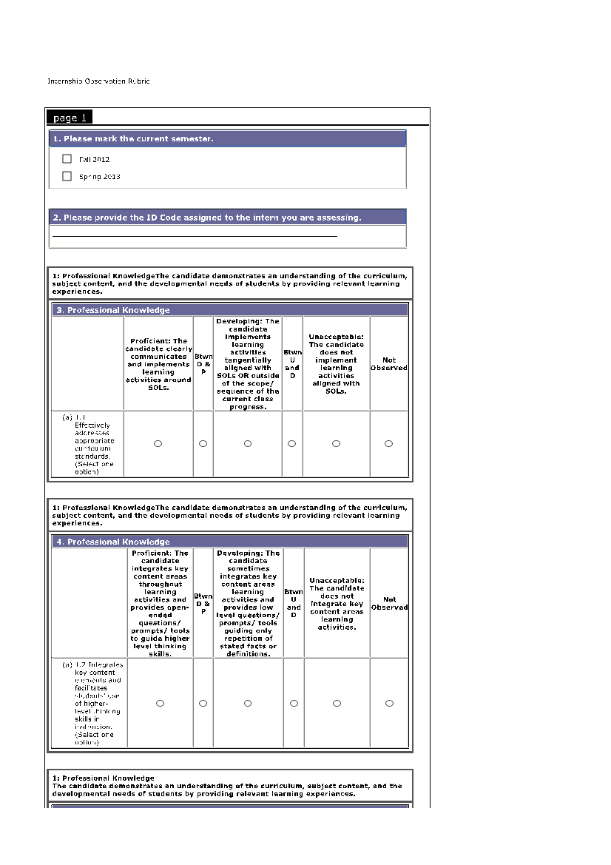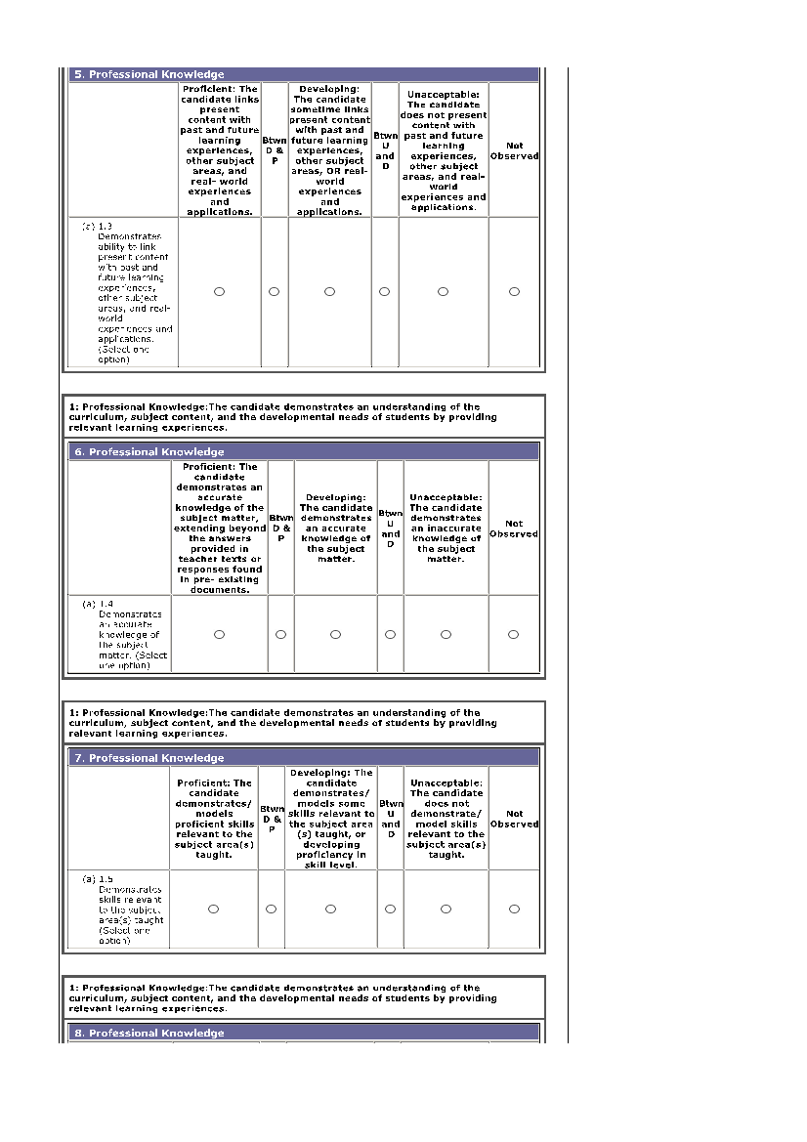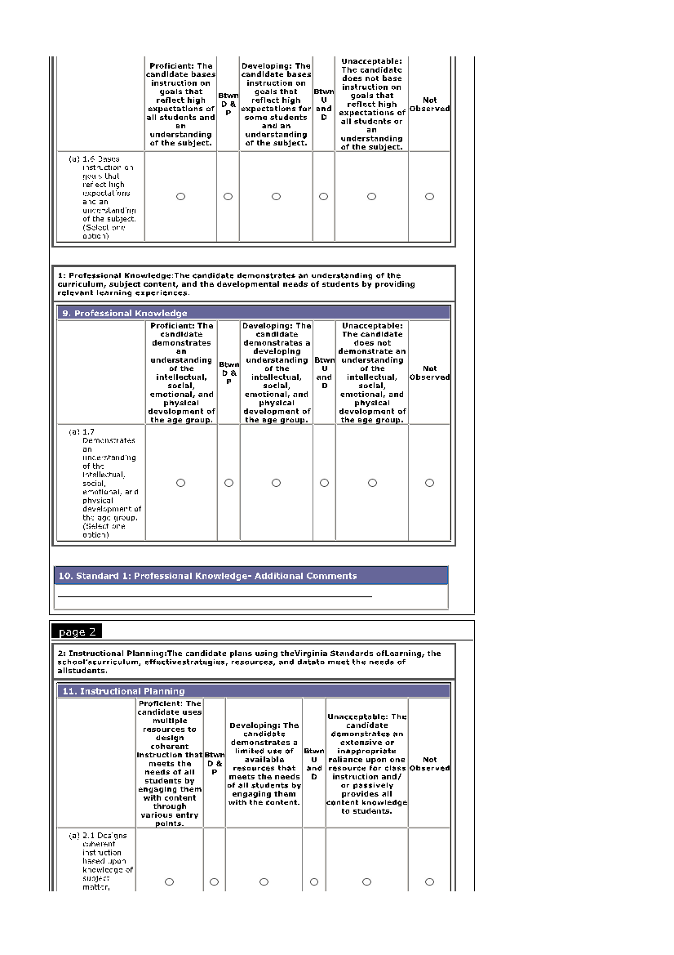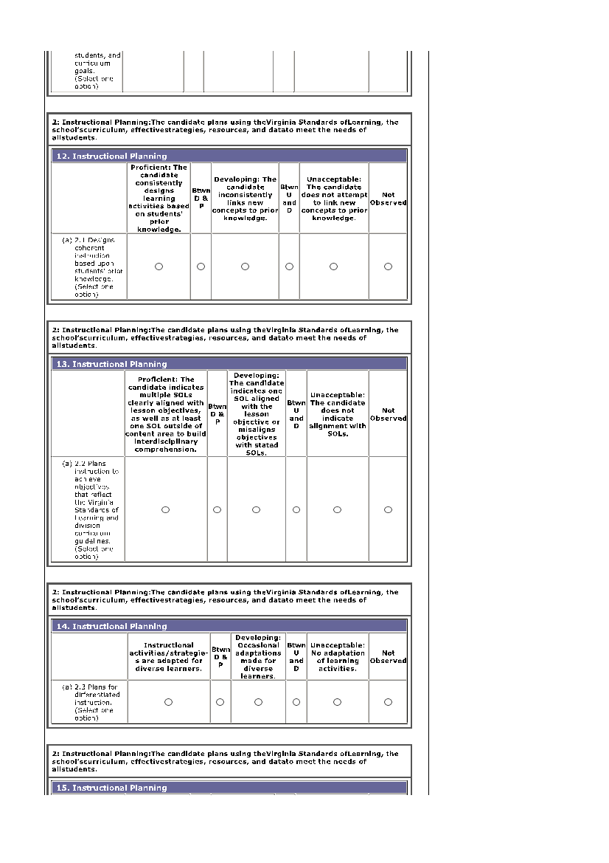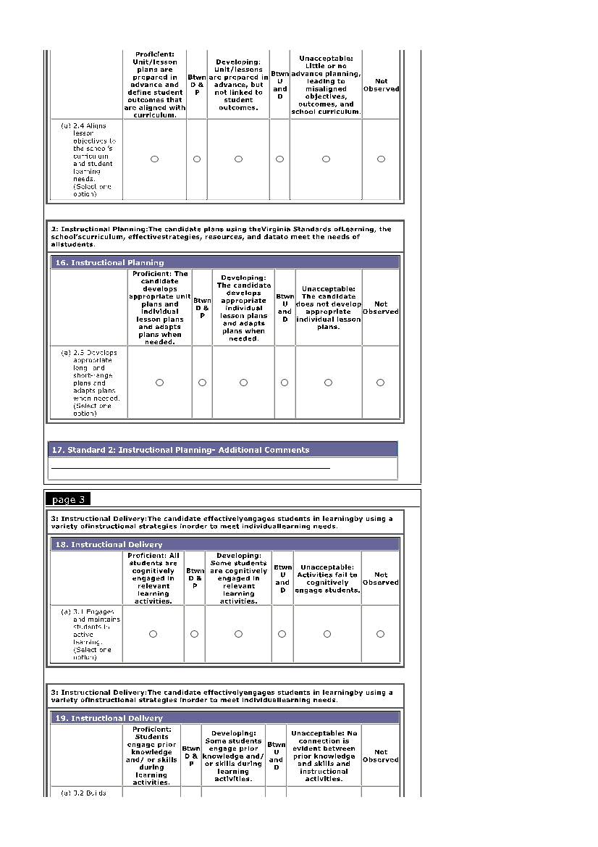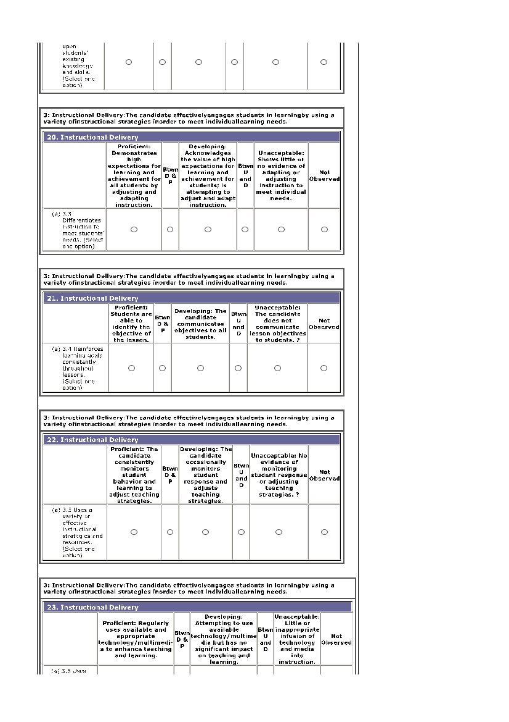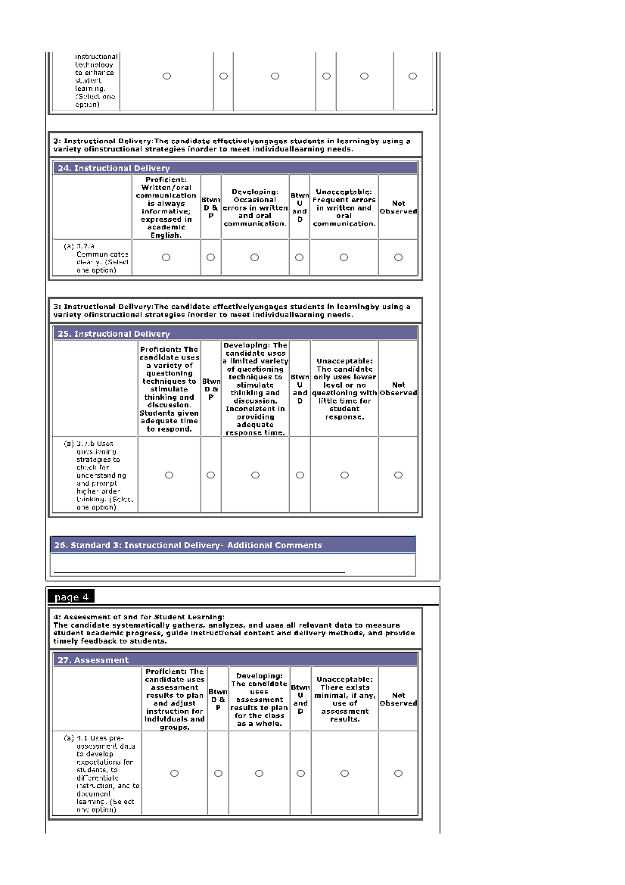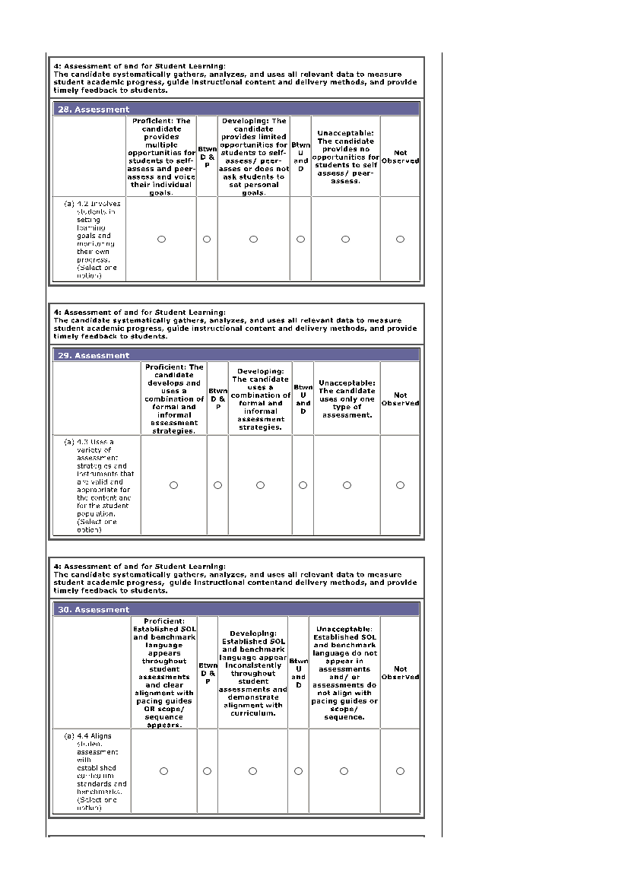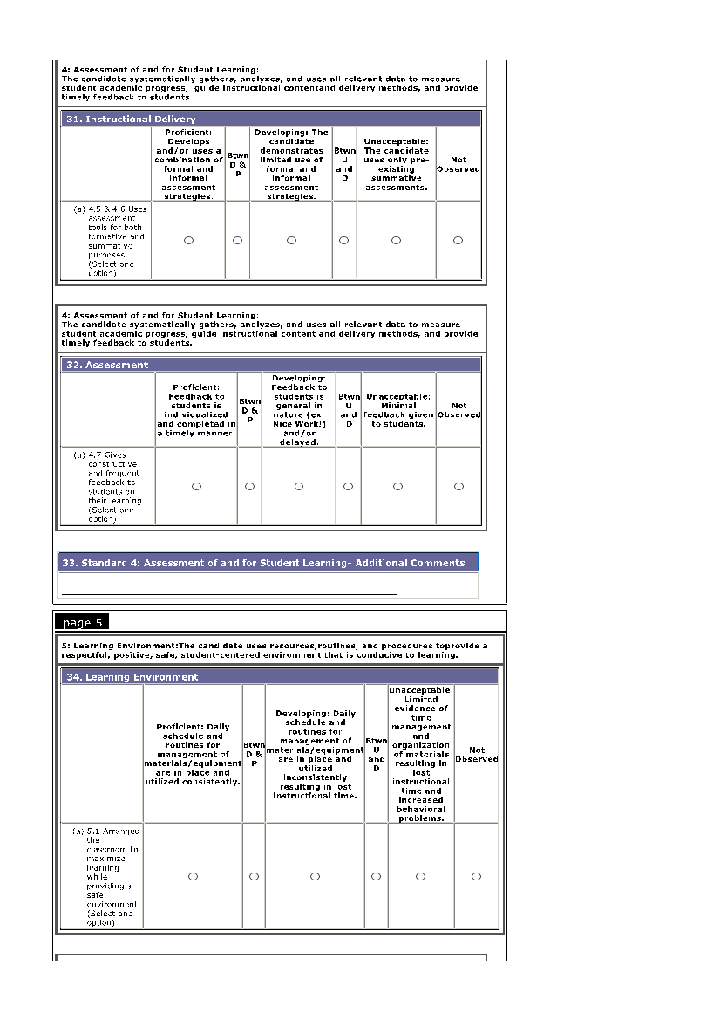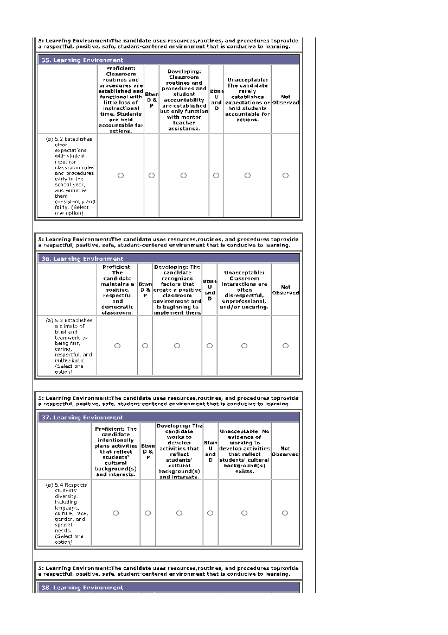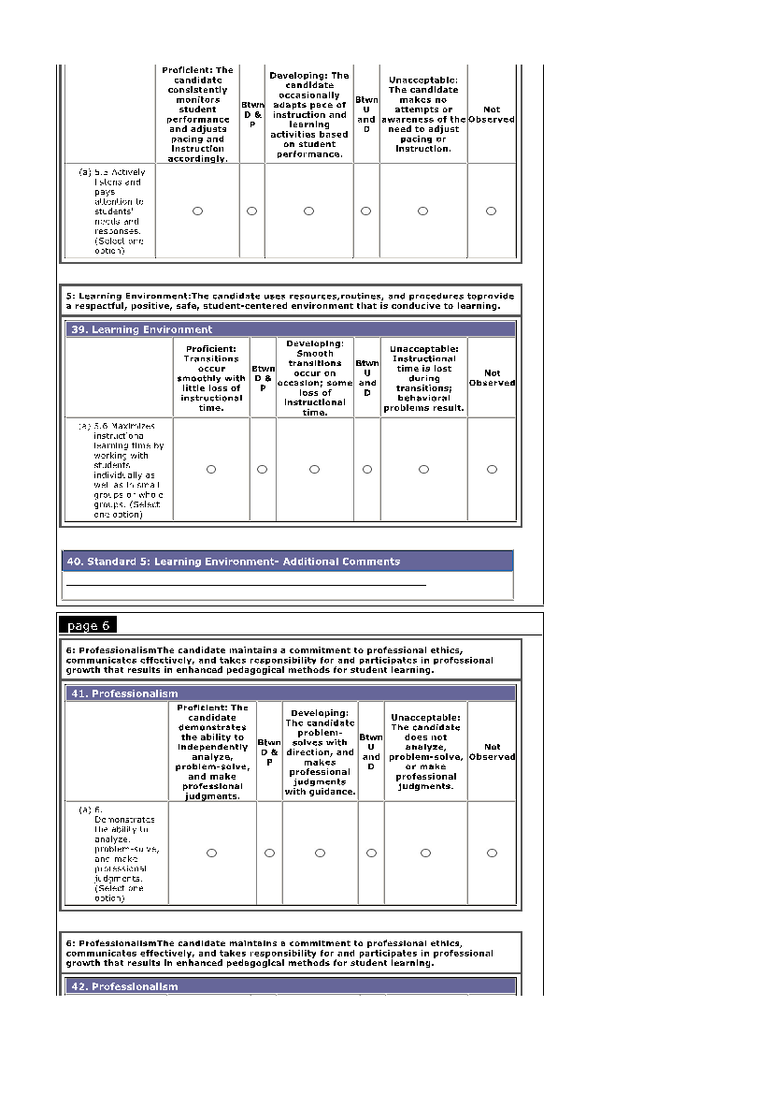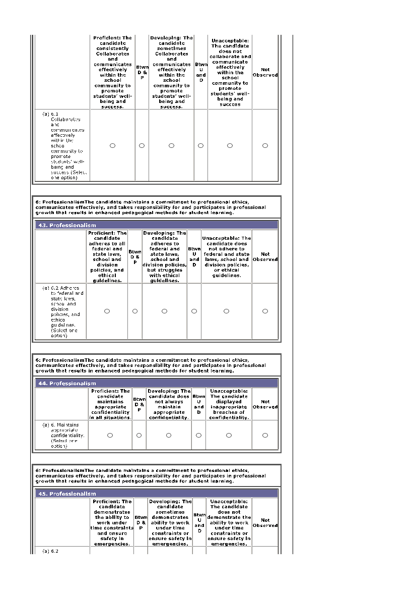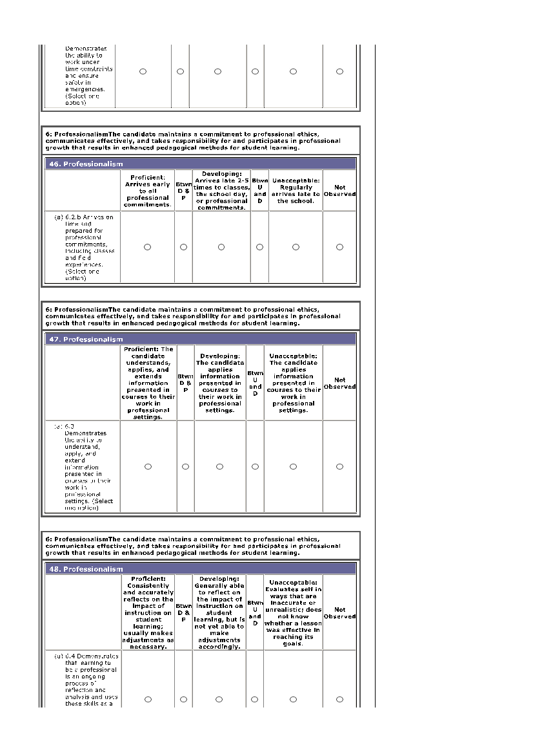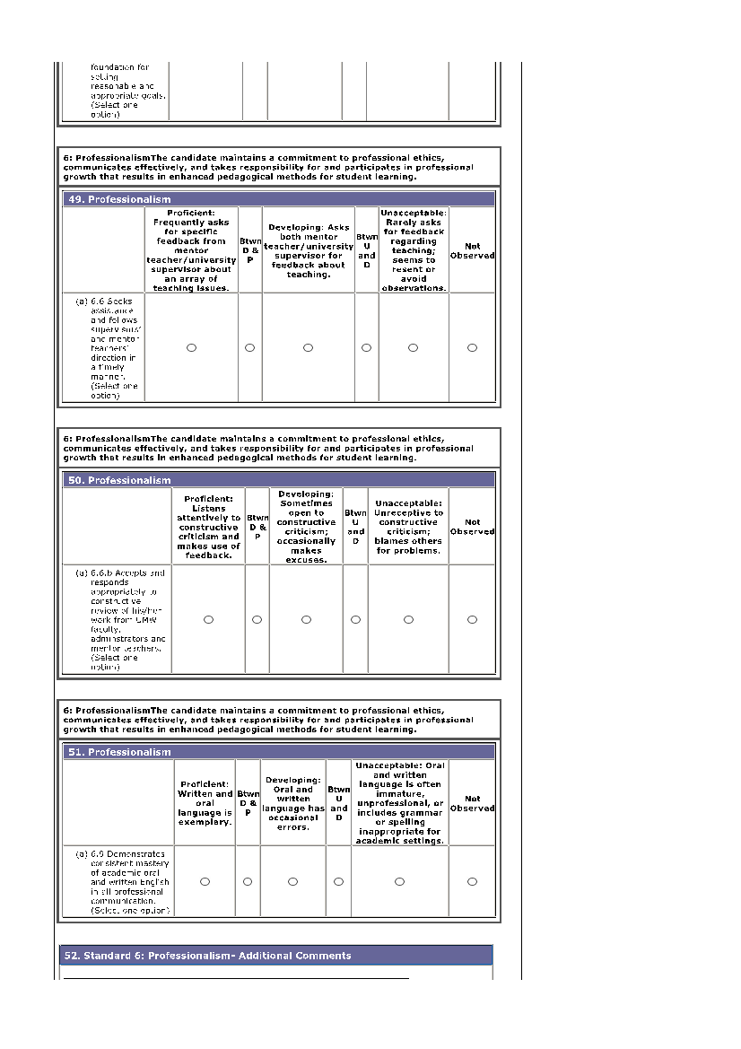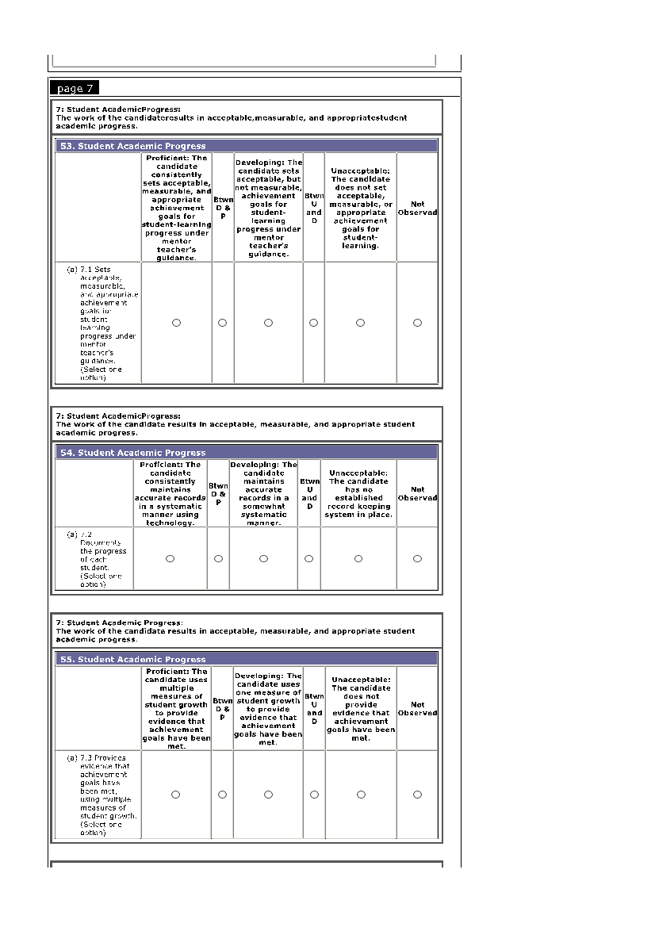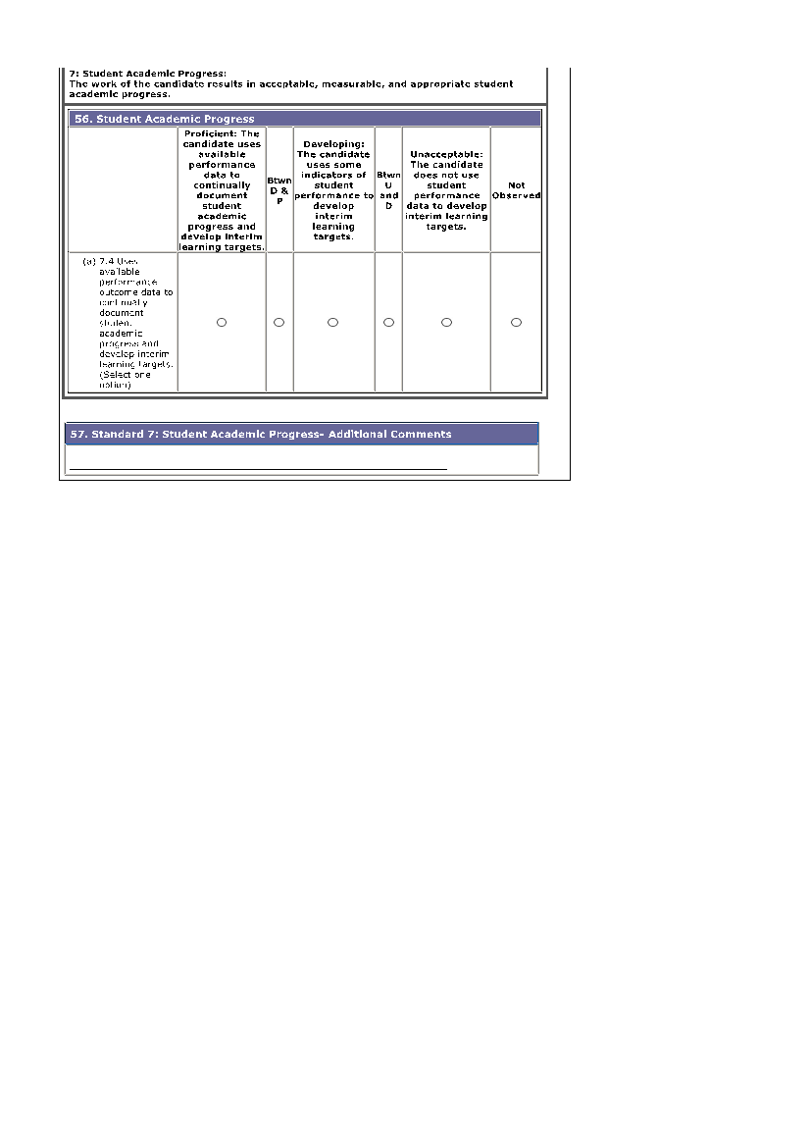

Appendix E: Internship Impact Study and Rubric
IMPACT STUDY

The Impact Study is the capstone product for the initial teacher licensure program. The purpose of the impact study is an important one—to determine whether or not the teacher candidate has a positive impact on all students’ learning.

Under the direction of a mentor teacher and with guidance from a university supervisor, the teacher candidate will select one of the units to be taught for the Impact Study. The unit will be provide evidence of the ability to plan, implement, and evaluate a unit of study designed to meet the needs of a group of learners in a school setting. The teacher candidate will also reflect teaching experiences to promote ongoing professional growth and development.

The instructional purpose of the unit, the content of the unit, the kind of unit, the duration of the unit, the plan for pre- and post-assessment, the lesson plan format, and the implementation schedule will be determined collaboratively by the teacher candidate, the Mentor Teacher, and the University Supervisor.

Impact Study
Demographic Profile - narrative description of the community, school system, school, and classroom

Unit Goals/objectives for the unit

Assessment Plan
Plan to pre-assess student learning (Pre-test)
NOTE: Analyze the data (after administering the Pre-test) to determine if modifications need to be made to the unit plan in part or whole, or if modifications need to be made for specific learners or groups of learners. If necessary, modify preliminary lesson plans in light of the pre-assessment data.
Plan to post-assess student learning (Post-test)

Methods of assessment used throughout the unit (reports, presentations, rubrics, etc.)
NOTE: Identify the day-to-day assessment methods and instruments in daily lesson plans.

Daily Lesson Plans

Data Analysis
Graphic display of pre-/post-assessment differences and learning gains
Analysis of data for individuals and groups (e.g., disaggregated by ethnicity, gender, special needs)
Calculation and charting of learning gains for individuals and groups
Summary and interpretation of the data analysis and impact of the unit on the students
Plans for addressing needs of learners who did not do well

Impact Study Reflection
What worked well and how do you know?
What didn’t work well and how do you know?
How will you apply what you learned to the next unit?
IMPACT STUDY RUBRIC

Teacher Candidate Date
School Grade Level/Subject
Mentor Teacher University Supervisor(s)

Rating Categories: 0 = missing 1 = unacceptable 2 = developing 3 = proficient

 |  | 0 | 1.0 | 2.0 | 3.0
IMPACT UNIT PLAN
Demographic Profile
The candidate provides a narrative description and demographic profile of the community, school system, school, and classroom.
Unit Goals
The candidate translates goals into specific knowledge, skills, and dispositions for diverse learners aligned with the Standards of Learning.
Assessment Plan
The candidate pre-assesses student knowledge, skills, and dispositions and uses that information to plan effective instruction; uses various authentic summative assessment strategies to determine learning gains; and employs authentic formative assessment strategies to monitor student learning on a daily basis.
Daily Lesson Plans
The candidate incorporates multiple instructional strategies and organizes students for learning in various ways for various instructional purposes. The candidate modifies instruction to meet the needs of individuals and groups of students. The candidate designs meaningful learning experiences for diverse learners.
Data Analysis
The candidate summarizes assessment data in a graphic display. The candidate analyzes and interprets data for individual students and groups of students. The candidate uses assessment results to plan remediation for individual students.
Impact Study Reflection
The candidate reflects on the learned from the experience; acknowledging what worked and what didn’t; and seeing how to apply what was learned to future teaching experiences.
2.0 or better on each section of the rubric is required to earn a passing score | _________ (point total)
Evaluated by: _________________________________________ Date: _____________________________

Date Returned to candidate for revision (if needed)__________________________________________________

Date Resubmitted to University Supervisor:_______________________________________________________

Re-evaluated by: __________________________________________ Date: _____________________________

Appendix F: Internship E-portfolio rubric
*Adapted from Vandervelve, J. (2012)

Appendix G: Action Plan for Interns Who Struggle

UNIVERSITY OF MARY WASHINGTON
COLLEGE OF EDUCATION
FREDERICKSBURG, VIRGINIA

ACTION PLAN

Teacher Candidate: | University Supervisor:
School Assignment: | Mentor Teacher:

AREAS OF CONCERN:

- Professional Knowledge
- Instructional Planning
- Instructional Delivery
- Assessment of and for Student Learning
- Learning Environment
- Professionalism
- Student Academic Progress

PLAN OF ACTION:

The teacher candidate will demonstrate the following items by [date].

References
Barrett, J. R. (2006). Developing the professional judgment of preservice music teachers: Grading as a case in point.
Journal of Music Teacher Education, 15(2), 8-20.
Darling-Hammond, L. (2010). The flat world and education: How America’s commitment to equity
will determine our future. New York: Teachers College Press.
Darling-Hammond, L. & Sykes, G. (2004). A teacher supply policy for education: How to meet the
‘highly qualified teacher’ challenge. In N. Epstein (Ed.), Who’s in charge here?: The tangled web of school governance and policy (pp. 164-227). Denver: Education Commission of the States.
LePage, P., Darling-Hammond, L., Akar, H., Gutierrez, C., Jenkins-Gunn, E., & Rosebrock, K.
(2005). Classroom Management. In J. Bransford & L. Darling-Hammond (Eds.), Preparing teachers for a changing world: What teachers should learn and be able to do (pp. 327-357). San Francisco, CA: Jossey-Bass.
NCATE (2010). Transforming teacher education through clinical practice: A national strategy to prepare effective teachers. Retrieved
from: http://www.ncate.org/LinkClick.aspx?fileticket=zzeiB1OoqPk%3D&tabid=715 on July 20, 2012.
Vandervelve, J. (2012). A+ Eportfolio Rubric. Retrieved from: http://www.uwstout.edu/soe/profdev/rubrics.cfm
VDOE: Virginia Department of Education (2006). Designing a continuing of successful field experiences: A blueprint.
Retrieved from: http://www.doe.virginia.gov/teaching/regulations/successful_field_experiences_blueprint.pdf on July 20, 2012.

See Appendix G

