How to OPEN a Form Using Adobe
(Open the Business Meal Form from the Website)

If a PDF form will not open from the website, try the following steps:
USE GOOGLE CHROME AS THE BROWSER
- Click the three dots in the upper right corner
- Click Settings
- Click Extensions (on the far left side)
- Click Details in the Adobe tile
- Click Extension Options
- Make sure “Auto Open Converted PDFs in Adobe” is turned ON
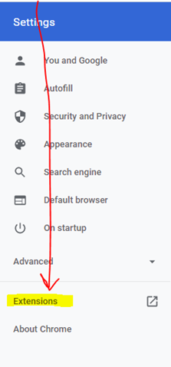
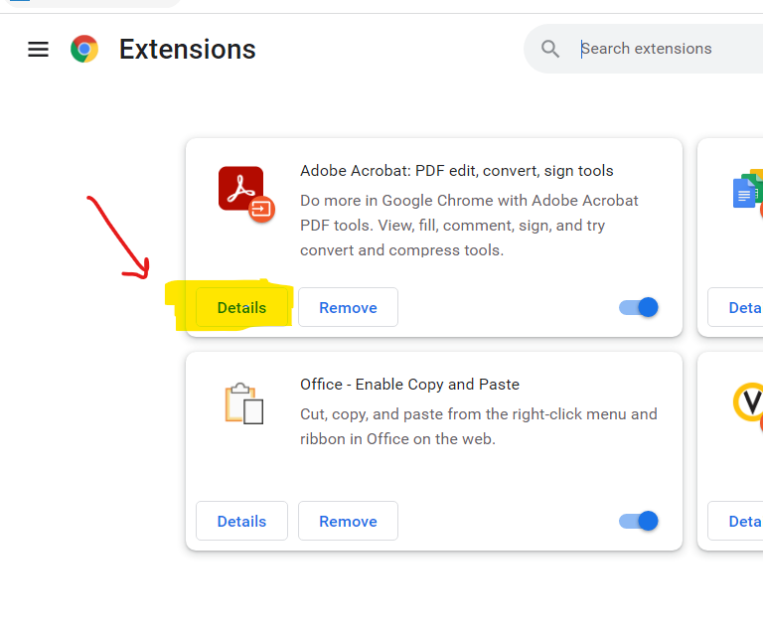
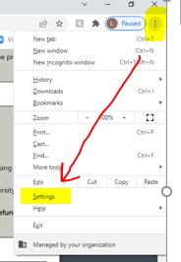
4
3
2
1
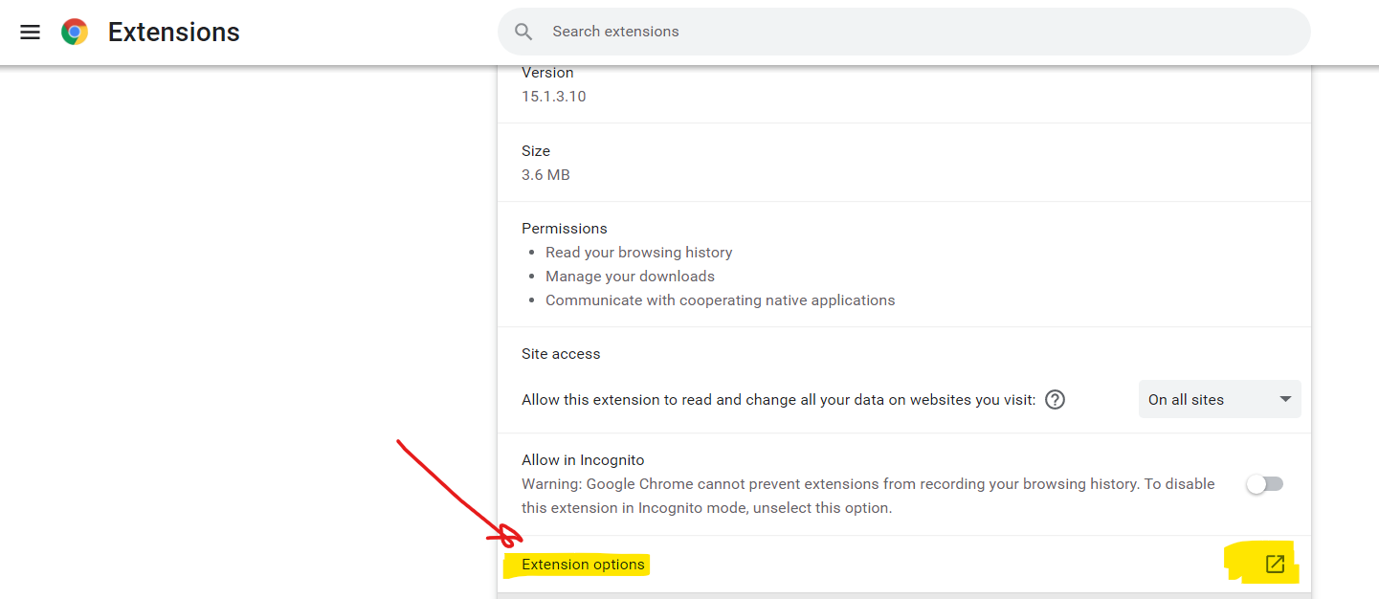
5
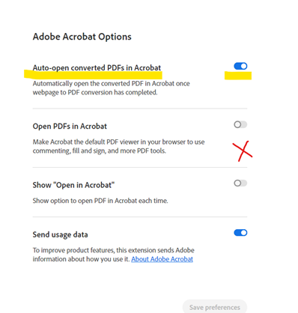
6

