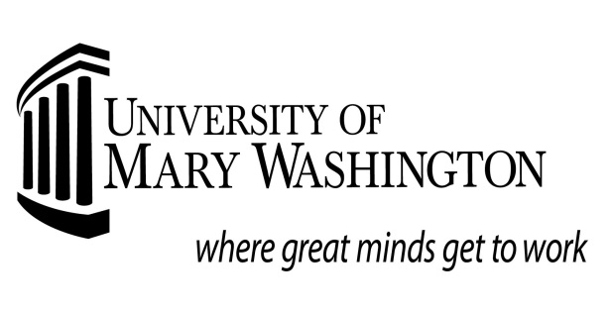

Satisfactory Academic Progress Appeal Form

Name: Date: UMW ID: Student’s Phone #
Instructions:
1. A thorough explanation of the circumstance not to exceed two pages. Incomplete information will not be sent to the committee.

• The serious and compelling circumstances that occurred during any semester in which you did not meet the standards for Satisfactory Academic progress, including prior years.
• What your responsibility for these events has been.
• How your circumstances have changed so your failure of the situation will not occur again.
• The steps you have taken to ensure you will make Satisfactory Academic Progress in the future.

2. Support Documentation
Written documentation or evidence that supports the reason(s) given in your statement. This might include a letter from your doctor, court documents, death certificates or copies of University documents such as approved requests for incompletes or withdrawals accompanied by posted grade changes on transcripts, etc. Financial hardship must be documented by bank statements, layoff notices, foreclosure notices, court documents, or other relevant legal documents. Please attach photocopies. Original documents will not be returned.

We must receive completed appeals with associated documentation no later than the following dates to be considered.
Fall: October 01 Spring: February 15 Summer: June 01

3. Academic Plan
Take the reverse of this form to your academic advisor and complete an academic plan to bring your grades/progress back to UMW Office of Financial Aid requirements. If your appeal is approved, you will have no more than three terms (must be concurrent) from the time your appeal is approved to meet Satisfactory Academic Progress requirements. Your plan can be for one, two or three terms depending on how long it will take for you to regain your eligible status.

OFFICE USE ONLY BELOW THIS LINE

Approved: (check one) Fall_____ Spring _____ Summer_____

Approved: Reason/Comments: _____________________________________________________________________

Denied: Reason/Comments: ______________________________________________________________________

Signature of Committee Member ___________________________________ Date _________________________

Signature of Committee Member ___________________________________ Date _________________________

Student has no more than three concurrent terms; beginning the term the appeal was approved, to meet University of Mary Washington Satisfactory Academic Progress standards. Failure to do so will result in the suspension of all financial aid.
Grade Point Needed for
SAP

0-29 1.65

30-45 1.80

46-59 1.90

60-89 2.00

90 + 2.00

Graduate 2.00

Semester One: Fall _____ Spring _____ Summer ____

Course Check if repeating this course Credit Hours Grade Needed

Course Check if repeating this course Credit Hours Grade Needed

Course Check if repeating this course Credit Hours Grade Needed

Course Check if repeating this course Credit Hours Grade Needed

Students who successfully
complete a minimum of 75% (no rounding up) of the credit hours attempted in an academic period are considered meeting UMW
course completion or
progress standards. An
academic period is normally the academic year consisting of the fall and spring semesters. Students who fail to meet course completion rates, but are approved for a waiver, must complete all hours attempted as stated under the academic plan or waiver.
Semester Two: Fall _____ Spring _____ Summer ____

Course Check if repeating this course Credit Hours Grade Needed

Course Check if repeating this course Credit Hours Grade Needed

Course Check if repeating this course Credit Hours Grade Needed

Course Check if repeating this course Credit Hours Grade Needed

Semester Three: Fall _____ Spring _____ Summer ____

Course Check if repeating this course Credit Hours Grade Needed

Course Check if repeating this course Credit Hours Grade Needed

Course Check if repeating this course Credit Hours Grade Needed

Course Check if repeating this course Credit Hours Grade Needed

I have reviewed and understand the terms described above. I understand that I must meet the conditions of this plan, for each term, to continue receiving aid for the following terms and that I must notify the Office of Financial Aid of any changes to my academic plan prior to receiving aid. Changes require a new appeal to be completed. I understand that my appeal has been approved for federal loan and grant programs (if eligible) excluding the Supplemental Opportunity Grant. The waiver does not include federal, state and institutional programs that require satisfactory academic progress or specific grade point average minimums that may not be waived. As a result of this determination, I will only be considered for Federal Direct loan programs and the federal Pell Grant program. I also understand that I must request a review of these academic requirements for continued eligibility after grades for each term have posted to my academic record.
I will not be automatically awarded for continuing terms.

Student Name Student Signature Date

Advisor Name Advisor Signature Date

