Temporary Employment Contracts
The University has a contract to provide temporary employment services. The contract administrator is the Recruitment Manager in the Human Resource (HR) department. The following eVA procedure is followed after:

- A discussion with the HR department
- Verification with budget on the expense (if needed)
- A discussion with the supervisor to determine if overtime pay is expected
- A completed Request for Temporary Personnel Form

Purchase Orders will probably be initiated by type of hire needed and length of term. For instance, you may have one order for Office Workers for a 6 month term, and you may have a separate Purchase Order for Labor for the entire fiscal year. Sample below show Office Personnel.

Log into eVA and select Shop Now

Step 1. On the My Home tab -Add Title.

Title: Insert a title for easy identification in your folder that first states the name of the hiring department (Office of the President in the sample below), followed by a basic description of the type of temporary assistance requested.

On Behalf Of: Change from your name to Birriel, Marilyn. Marilyn’s PCard and alias will show as seen below.
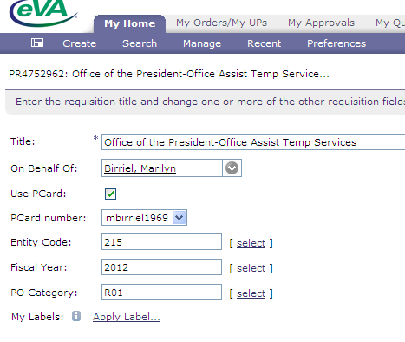
On the bottom right of the form, select Next to move to Step 2. 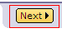

Step 2. Add Items page
In this step, you will be adding at least two line items. The first line item will be for the basic hourly rate. The second line item will reflect overtime pay.

Select Create Non-Catalog Item.
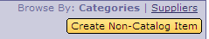

Enter the following information within the fields:

Full Description – the contract administrator will add to or change the information you provide in this field. Add this basic description:
Temporary Personnel required for (insert name of position) services for the period of (insert time period. You may use the full fiscal year, for the time frame, if desired. Credit card is to be charged as services are rendered and approved, based on the weekly time card, per employee.

Commodity Code – Enter the NIGP code 96269 in the Field Name search (Temporary Personnel Services)

Supplier – The contract administrator will change this field based on the vendor selected to supply the temporary service. You may add Temporary Solutions, one of our current suppliers, as a placeholder.

Contact –The contact should default based on the Supplier.

Contract List – From the drop down, select Item on contract but number not on list.

Contract Number – Enter 10-28.

Quantity – Most personnel are paid by an hourly rate. Insert the approximate number of hours you will need, based on the length of this contract. This is an estimate only and can be easily changed.

Unit of Measure – Select hour from the drop down .

Price – Enter in $1.00. The Contract Administrator will complete the cost per hour for you. {Note- if you are responsible for budgeting. Temporary services are expensed from your Operating budget.}

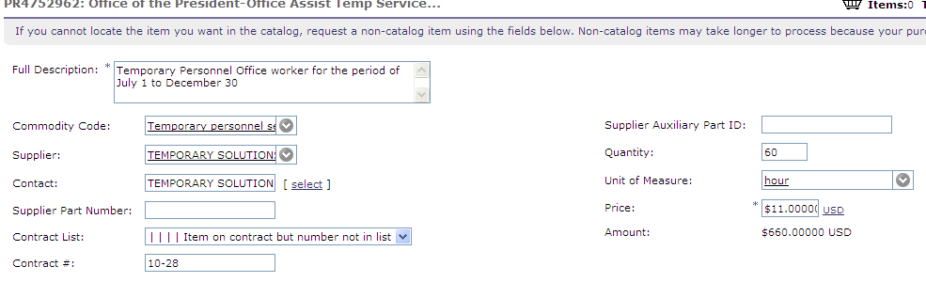

When complete, select Update Total > OK and then .

Note: Temporary employees with pay differentials (ie shift work), or those with differing pay rates; may require separate line items on the purchase order. If unsure, talk to HR to help determine the best tracking method for your department.

Step 3. Add Accounting Details, Line 2 for Overtime pay, and attach the HR form.

Select Edit from line one and scroll to the middle of the page to the Accounting by Line Item fields.

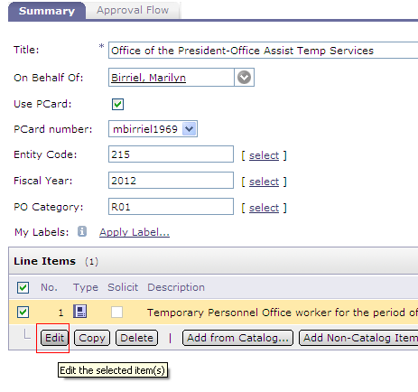
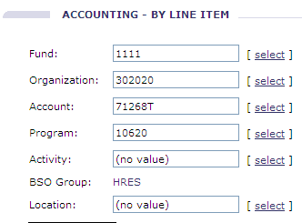

Enter the FOAP information for this service. The account code 71268T is specifically used for Temporary employment services. Note: Temporary Services are charged to your departmental Fund, Org., and Program code.

Leave the Location field blank.

Scroll down to the end of the page. {Purchase Order Shipping and Comments sections are handled on the next form}

Select OK to return to the Summary tab.

Using the Copy function, copy line 1 to line 2.
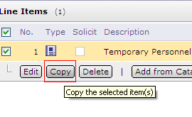
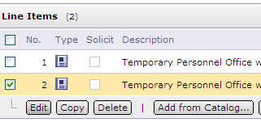

On line 2, select the Edit button to change the line description to read “Overtime Pay”.

If you are not expecting to pay Overtime (which will be more than the basic rate per hour), Make a note in the description that overtime pay must be approved in advance. The Price will be zero.

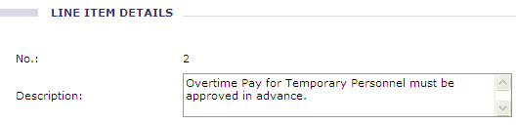

If you are expecting overtime, estimate the number of hours. HR will insert the rate for you.

Select OK to return to the Summary Tab.

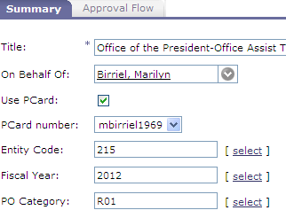
At the top of the Summary tab, confirm the following fields have proper information:

On Behalf of: Marilyn Birriel
Use PCard is checked
PC number belongs to Marilyn
Correct Fiscal Year
PO Category is R01

Scroll down to the bottom of the page to insert the HR form to the requisition. Select the Add Attachment button, then Browse to the form on your desktop.
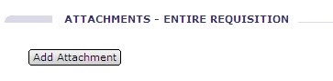

When the document is attached, select the Visible to Supplier check box and then select OK to complete this process and return to the Summary tab.

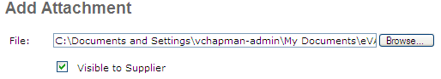

Step 4. Add Marilyn as a Watcher to the Requisition,
This is necessary for HR tracking the order once the purchase order is returned to you.

Scroll UP the Summary Tab to select the Approval Flow tab. Click on the Approval Flow Tab to open.

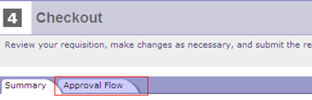

On the Add approver to approval flow field, use the down arrow and search by Birriel
Select the Watcher radio button
Select the Add approve to the approval flow as the first or subsequent approver

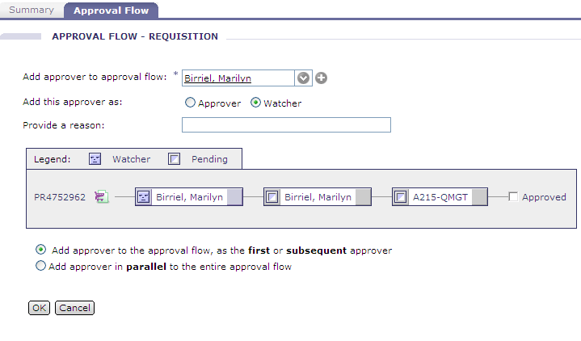
When this form is complete, select the OK button.

Submit button to submit the order, or Exit to save the request in Composing for later submission.

A successful purchase order submission will provide the following page in eVA:

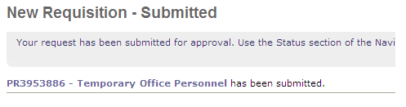
Your order will route to Marilyn in the Human Resource Department. Marilyn will open the order, submit the attached form to contracted vendors, and eventually complete the purchase order according to specifications.

Marilyn will return the requisition back to you for final approval and submission to the vendor. Your SPCC card will be charged and you will be responsible for the Works transaction coding and sign off and any future change order requirements.

Final Approval and Submission

The Personnel Requisition will be returned to you by Marilyn . She will change the On Behalf Of from her name to your name and will select the Pcard box to charge your credit card. You will know Marilyn is ready for you to take possession of the order when you receive the following email in your Outlook mailbox:

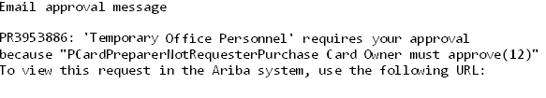
https://ariba.epro.cgipdc.com:443/Buyer/Main/ad/webjumper?partition=pcsv&username=lnorflee1&passwordadapter=SingleSignOnWSAdapter&itemID=5yi58n5.1k&awcharset=UTF-8

Selecting the URL will bring you to the eVA Login page.

Log into eVA to Review the Requisition.

eVA routes you to the Approval Summary page. You may approve the order immediately, but it would be advisable to review the information Marilyn has placed on your order.

To review the order, open the PR number from the left side of the form, directly under your name.
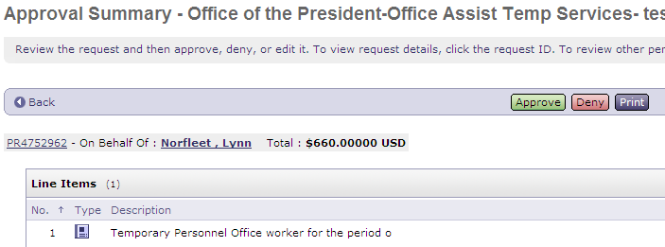

You will notice the following upon review:

- The On Behalf Of field is now your name
- The PCard box is checked {assuming the vendor accepts the card}
- Your PCard Number {alias} is shown

Note the line item description, length of contract, rate of pay and hours. If satisfied that all requirements are met, use the back link to return to the Approval Summary Page to Approve the order. The fully approved order will be maintained on the My Home tab, with the My Documents window in eVA.

Purchase Order Contract Tracking

Ideally, the dollar value of the purchase order will exactly match the amount actually expensed for the service. However; it is very likely that the eVA purchase order will require a change due to one of the following:

- Services are no longer required,
- The final cost of the contract is higher or lower than expected,
- Contract terms and conditions have changed, or
- The vendor can no longer meet your requirements.

You may need to work with the Human Resource Office on the possible change requirement or circumstance, but the eVA Change Order is the responsibility of the department Buyer. Buyers may contact TESS or Purchasing for assistance with contract expense tracking or the Change Order

Timecard, Invoice and Works

Every Friday, the temporary employee will submit a timecard to the supervisor to verify the numbers of hours worked and rate of pay. The approved time card authorizes the contractor to charge the weekly rate to the SPCC.

By the following week, the vendor should send you a paid invoice and a copy of the corresponding timecard. Verify hours on the timecard reflect actual posting in Works prior to Works sign off. Remember to code the expense to account code 71268T. Contact HR if discrepancies are found in hours, pay, or if a paid invoice is not received in a timely fashion.

Note! Maintain both the invoice and the timecard within the Purchasing file. This is required backup documentation. If the vendor submitted a time card to you with the hire’s social security number, please black off the number as best you can and request that the number be omitted in future cards.

